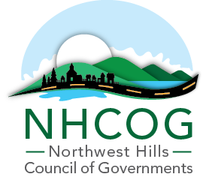

**SPECIAL MEETING OF THE EXECUTIVE COMMITTEE**

**MINUTES – May 6, 2024**

**Members or Representatives in Attendance:**

New Hartford, Dan Jerram, Chair

Harwinton, Mike Criss, Vice-Chair

Roxbury, Patrick Roy, Secretary

Morris, Tom Weik, Treasurer

Cornwall, Gordon Ridgeway, At-Large

Torrington, Mayor Elinor Carbone, At-Large

**Members Absent:**

None

**Others Present:**

Robert Phillips, Executive Director – NHCOG

Rista Malanca, Director of Community and Economic Development – NHCOG

1. **Determination of Quorum and Call to Order:**

Chairman Jerram called the meeting to order at 8:07AM.

1. **Review of the Draft FY24-25 NHCOG Annual Budget Workplan**

The Executive Director and Director of Community and Economic Development presented the detailed explanation of the budget numbers and the workplan associated with the line items of revenue, expenditures and contract/pass through accounts. The committee was satisfied with what was presented and offered some direction on adding additional language for explanation purposes prior to forwarding on to the board for review at their next monthly meeting prior to formal approval in June.

*No motions were made.*

1. **Approval of the October 12, 2023 Special Meeting Minutes**

*Motion (Weik) to approve the minutes as presented, seconded (Roy) and approved 6-0.*

1. **Adjournment:**

*Motion (Roy) to adjourn, seconded (Weik). The meeting was adjourned.*