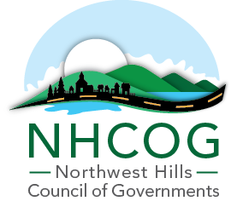

SPECIAL MEETING OF THE EXECUTIVE COMMITTEE

MINUTES – June 7, 2023

Members or Representatives in Attendance:
Canaan (Falls Village), Henry Todd, Chair
North Canaan, Charlie Perotti, Secretary
Morris, Tom Weik, Treasurer

Members Absent:
Harwinton, Mike Criss, Vice-Chair
New Hartford, Dan Jerram, At-Large
Barkhamsted, Don Stein, At-Large

Others Present:
Robert Phillips, Executive Director – NHCOG

- Determination of Quorum and Call to Order:

Chairman Todd called the meeting to order at 2:32PM. There was no quorum to take action.

- Draft FY23-24 NHCOG Annual Budget Review and Endorsement for Board Approval and Regional Service Grant (RSG) Statement of Work.
The Executive Director presented the draft annual budget and discussed it line by line as well as the NHCOG staffing plan moving into the 23-24 Fiscal Year, as well as the fact that it will need to be revised to reflect new funding sources that are expected over the next week or two. Since the budget must be approved, the Executive Director suggested to present it at tomorrow’s annual board meeting for approval and then hold a special meeting prior to the start of the FY on July 1st to approve an amended budget with new funding sources.

No motions were made.

Approval of Minutes of the Special Meeting of the Executive Committee – April 26, 2023

No motions were made.

Adjournment:

The meeting adjourned at 3PM

