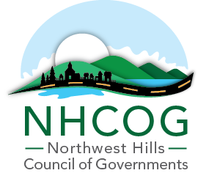

NOTICE OF SPECIAL MEETING

DATE: Thursday, June 29th, 2023
TIME: 10:00 AM – 10:30 AM
LOCATION: NHCOG Office, 59 Torrington Road, Suite A-1, Goshen, CT

AGENDA
(Chairman Henry Todd; Vice Chairman Mike Criss; Secretary Charlie Perotti; Treasurer Tom Weik)

10:00 AM Call to Order and Opportunity for Public Comment. Henry Todd, Chairman.

10:05 AM ACTION – Approval of Revised NHCOG Annual Budget for 2023-2024 Fiscal Year.

10:25 AM ACTION - Authorization for NHCOG to Participate in the Capitol Region Purchasing Council (CRPC) for the 2023-2024 Fiscal Year.

10:30 AM Other Business as Raised by Members and Adjournment.

